Shrinkage correlation: USDJPY and EURGBP
Method 08 / eight-major panel / delta = 0.2 and Ledoit-Wolf / Alpari D1 full available history

Study setup
Logical pair: USDJPY , EURGBP
Broker symbols: USDJPY_i , EURGBP_i
Snapshot: 2026-11-03_majors_alpari_D1
Timeframe: D1
Common eight-major panel window: 1999-01-06 to 2026-11-02 (UTC bar dates)
Panel matched return count n: 7127
Dropped unfinished last bar dated 2026-11-03 UTC after a tick-volume check against the prior complete day.
Fixed shrinkage: delta=0.2, mu=3.9170889e-05 (mean of diag(S))
Ledoit-Wolf estimated delta: 0.0042157642
Panel symbols: EURUSD, GBPUSD, AUDUSD, NZDUSD, USDJPY, USDCHF, USDCAD, EURGBP
Complete matched rows (Excel): USDJPY-EURGBP_Shrinkage_D1.xlsx
Complete matched rows (HTML table): USDJPY-EURGBP_Shrinkage_D1_data.html

Method carried forward
Shrinkage blends the sample covariance matrix S of matched daily log returns of close, ln(close_t / close_t-1), toward a simple target, then converts the shrunk covariance into correlations. Quotes are not inverted. This experiment builds one common calendar across all eight majors, forms S with the unbiased n-1 divisor, then reports two shrinkage specs: fixed delta = 0.2 with mu equal to the average sample variance (mu * I target), and sklearn Ledoit-Wolf with its estimated delta. Pair reports pull rho_ij from those panel matrices. Same-panel Pearson r is a side check only. Shrinkage improves conditioning; it is not a cause, not a lead, and not a trading signal.

Results
pearson_r | rho_02 | rho_LW | rho_02_minus_r | rho_LW_minus_r | delta_LW
-0.129377 | -0.097228 | -0.128652 | 0.032149 | 0.000725 | 0.00421576

Conclusion
Over the common 7127-day eight-major panel for USDJPY and EURGBP (broker quote directions unchanged), fixed-delta shrinkage correlation at delta=0.2 is -0.0972 (negative, weak linear link in this sample). Ledoit-Wolf rho is -0.1287 with estimated delta=0.004216. Same-panel Pearson r is -0.1294 (rho_02 minus r = 0.0321; rho_LW minus r = 0.0007). This does not establish cause, lead-lag, or a lasting trading rule.

Charts
Daily closes
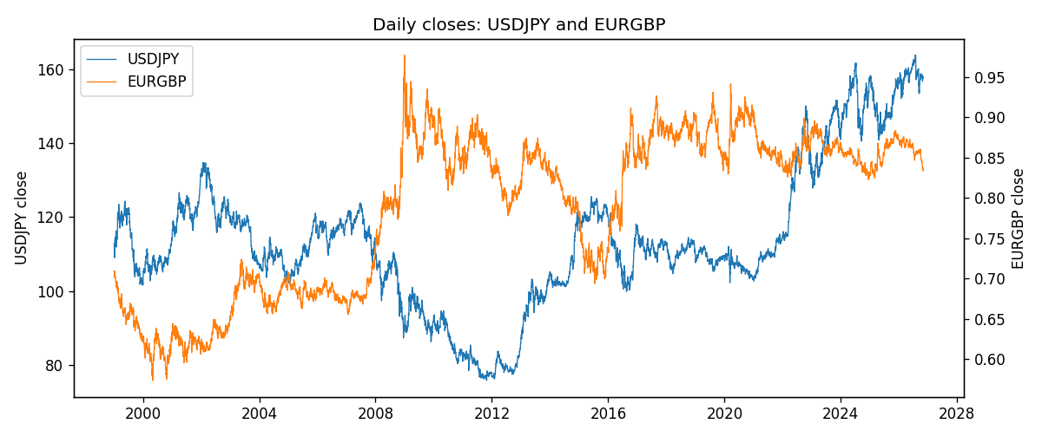
Daily log returns
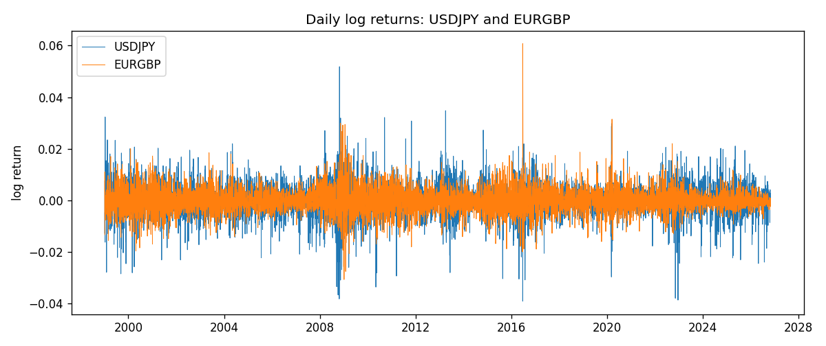
Log-return scatter
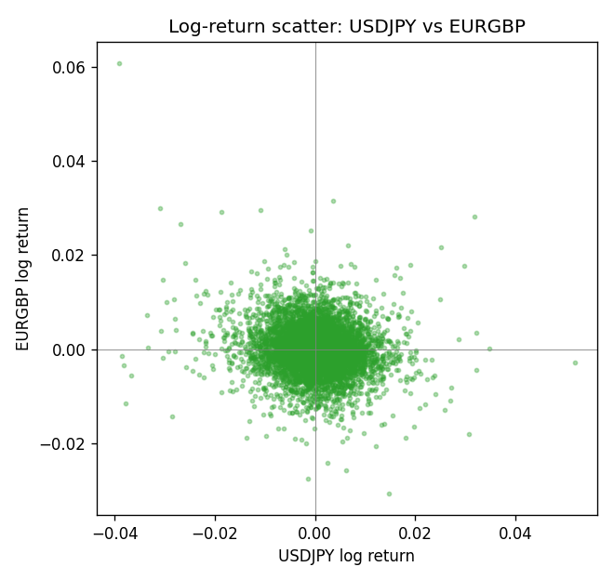

Data report
Every panel row for this pair slice is stored in the sibling Excel workbook named USDJPY-EURGBP_Shrinkage_D1.xlsx. Full-panel covariance and correlation matrices are saved once under outputs/ as CSV files. Embedding all rows as a Word table is impractical at this length; the Word file holds the column list, column summaries, and the first and last 15 matched rows.
Columns: time, USDJPY_open, USDJPY_high, USDJPY_low, USDJPY_close, USDJPY_tick_volume, USDJPY_spread, USDJPY_real_volume, USDJPY_log_return, EURGBP_open, EURGBP_high, EURGBP_low, EURGBP_close, EURGBP_tick_volume, EURGBP_spread, EURGBP_real_volume, EURGBP_log_return
Column summaries (panel rows)
column | count | mean | std | min | 25% | 50% | 75% | max
USDJPY_open | 7127 | 113.80058 | 19.291864 | 75.693 | 104.3005 | 110.961 | 120.7475 | 163.824
USDJPY_high | 7127 | 114.29785 | 19.353625 | 76.001 | 104.822 | 111.42 | 121.29 | 163.978
USDJPY_low | 7127 | 113.2782 | 19.219415 | 75.402 | 103.814 | 110.515 | 120.2 | 163.628
USDJPY_close | 7127 | 113.81424 | 19.307121 | 75.811 | 104.298 | 110.98 | 120.725 | 163.851
USDJPY_tick_volume | 7127 | 107141.8 | 179947.68 | 197 | 10056 | 53577 | 93233 | 1803508
USDJPY_spread | 7127 | 20.095973 | 17.5534 | 0 | 6 | 11 | 30 | 50
USDJPY_real_volume | 7127 | 3.5056645e+10 | 1.6155964e+11 | 0 | 0 | 0 | 0 | 3.8834203e+12
USDJPY_log_return | 7127 | 5.336e-05 | 0.00621278 | -0.03908203 | -0.00319557 | 0.00013026 | 0.00340928 | 0.05184024
EURGBP_open | 7127 | 0.78791082 | 0.09637243 | 0.5734 | 0.6884 | 0.83449 | 0.8655 | 0.9769
EURGBP_high | 7127 | 0.79099288 | 0.09674788 | 0.5789 | 0.6906 | 0.83742 | 0.868415 | 0.9799
EURGBP_low | 7127 | 0.78520819 | 0.09619038 | 0.5682 | 0.6864 | 0.83222 | 0.86303 | 0.9661
EURGBP_close | 7127 | 0.7879552 | 0.09637142 | 0.5735 | 0.6884 | 0.83458 | 0.86556 | 0.977
EURGBP_tick_volume | 7127 | 87771.585 | 145890.89 | 332 | 6734 | 44866 | 82002 | 1424684
EURGBP_spread | 7127 | 21.129928 | 19.050945 | 0 | 4 | 13 | 40 | 50
EURGBP_real_volume | 7127 | 2.8086114e+10 | 1.3572254e+11 | 0 | 0 | 0 | 0 | 3.5726265e+12
EURGBP_log_return | 7127 | 2.379e-05 | 0.00487339 | -0.03067367 | -0.00262314 | -9.978e-05 | 0.00256668 | 0.06075387
First 15 panel rows (selected columns)
time | USDJPY_close | EURGBP_close | USDJPY_log_return | EURGBP_log_return
1999-01-06 | 112.77 | 0.7019 | 0.0075660159 | -0.013303338
1999-01-07 | 111.33 | 0.7097 | -0.012851583 | 0.011051402
1999-01-08 | 110.8 | 0.7062 | -0.0047719894 | -0.004943862
1999-01-11 | 109.02 | 0.7053 | -0.016195423 | -0.0012752393
1999-01-12 | 112.6 | 0.7077 | 0.032310364 | 0.0033970309
1999-01-13 | 113.52 | 0.708 | 0.0081373171 | 0.00042381861
1999-01-14 | 113.52 | 0.7066 | 0 | -0.0019793588
1999-01-15 | 114.15 | 0.7012 | 0.0055343401 | -0.0076715819
1999-01-18 | 114.16 | 0.7017 | 8.7600193e-05 | 0.00071280921
1999-01-19 | 113.52 | 0.7007 | -0.0056219403 | -0.0014261269
1999-01-20 | 112.91 | 0.7021 | -0.0053879917 | 0.0019960086
1999-01-21 | 113.87 | 0.7016 | 0.0084664056 | -0.00071240297
1999-01-22 | 114.56 | 0.7004 | 0.0060412564 | -0.0017118406
1999-01-25 | 113.72 | 0.6966 | -0.0073594164 | -0.0054402425
1999-01-26 | 113.86 | 0.6962 | 0.0012303367 | -0.00057438255
Last 15 panel rows (selected columns)
time | USDJPY_close | EURGBP_close | USDJPY_log_return | EURGBP_log_return
2026-10-13 | 158.305 | 0.84458 | -0.0018932826 | 0.00020130374
2026-10-14 | 158.317 | 0.84553 | 7.5800166e-05 | 0.0011241873
2026-10-15 | 158.024 | 0.84479 | -0.0018524319 | -0.00087557391
2026-10-16 | 157.964 | 0.84307 | -0.00037976126 | -0.0020380844
2026-10-19 | 158.517 | 0.84259 | 0.0034946841 | -0.00056950988
2026-10-20 | 158.16 | 0.83957 | -0.0022546642 | -0.0035906254
2026-10-21 | 158.108 | 0.83839 | -0.00032883504 | -0.00140647
2026-10-22 | 156.755 | 0.83682 | -0.0085942669 | -0.0018743924
2026-10-23 | 156.81 | 0.83751 | 0.00035080446 | 0.00082421033
2026-10-26 | 157.458 | 0.83762 | 0.0041238746 | 0.00013133309
2026-10-27 | 157.894 | 0.83595 | 0.0027651658 | -0.0019957343
2026-10-28 | 157.743 | 0.83651 | -0.00095679538 | 0.00066967224
2026-10-29 | 157.683 | 0.83553 | -0.00038043789 | -0.0011722209
2026-10-30 | 157.516 | 0.83351 | -0.0010596481 | -0.0024205543
2026-11-02 | 157.933 | 0.83426 | 0.0026438521 | 0.00089940465

